Dashboard Project
Onboarding system of Blue Origin
Prepared By: Aleksandrova Mariia, Loos Elizaveta, Musienko Nikolaii

- Business requirements and data preparation notes
Data preparation note
The data was generated using CLOUDE AI and underwent several transformation steps to produce the dashboard-ready dataset.
Data sources
  - HRIS provides employee master data: employee_id, first_name, last_name, gender, age, state, city, country, hire_date, department, job_title, manager_id, education_level, university, previous_experience_years, recruitment_source, is_active, termination_date, termination_reason.
  - Task management system supplies task-level information: log_id, employee_id, days_since_hire, task_category, task_name, task_status, completion_date, blocker_reason, satisfaction_with_task, comments, week_number, completed_flag, assigned_to_department, estimated_hours, actual_hours.
Data transformations
  - Onboarding status – Derived by grouping tasks per employee. An employee is considered “Completed” only when all tasks for that employee have a completed_flag = True. “In Progress” means at least one task is not yet completed and no active blocker exists. “Blocked” is assigned when any task has a blocker_reason populated and task_status = ‘Blocked’.
  - Task categories – Mapped from the task_category field; the five main categories are HR, IT, Orientation, Safety, and Training. These drive the volume breakdown charts.
  - Blocker analysis – Blocker_reason values are standardized into six categories: Manager unavailable, IT ticket backlog, Approval pending, Hardware shortage, Training not scheduled, Other. Counts are aggregated per week to show trends.
  - Satisfaction scores – Averaged by department (using employee.department) for tasks with a satisfaction_with_task value. Only departments with at least five responses are displayed to ensure statistical relevance.
  - Hours comparison – Estimated_hours (from the onboarding blueprint) and actual_hours (logged by task owners) are summed across all tasks for the reporting period. A variance is calculated to monitor efficiency.
  - Employee demographics – Used for filtering and segmentation (e.g., satisfaction by department, time to completion by recruitment source). Terminated employees are included for analysis but flagged with is_active = False and termination_reason.
Data quality and governance
  - Incomplete records (e.g., missing actual_hours for completed tasks) are excluded from efficiency calculations.
  - Blocked tasks without a blocker_reason are categorized as “Other” and investigated by the operations team.
  - Satisfaction scores below 1 or above 5 are considered invalid and omitted.
  - Employee records without a valid hire_date are rejected during load.
Alarm definitions (implemented as calculated measures in the BI tool)
  - Blocked status > 0 for >2 days → alert HR and manager.
  - Department satisfaction < 3.5 → trigger process review.
  - Actual hours > planned hours by >10% → initiate efficiency audit.
  - Blocker count increase >20% week-over-week → notify relevant functional team.
  - Overdue tasks >5 per category → assign additional resources.
Business requirements
The dashboard is intended to provide HR leadership, department heads, and operations managers with a real-time, single-source view of the onboarding lifecycle. The key business requirements are:
- Track onboarding completion – Monitor the status (completed, in progress, blocked) of all new hires across departments to ensure every employee successfully finishes onboarding.
- Identify and resolve blockers – Capture the frequency and type of onboarding blockers (e.g., manager unavailability, IT backlog) to prioritize corrective actions and reduce delays.
- Measure departmental satisfaction – Collect post-onboarding satisfaction scores to identify departments with low engagement and drive targeted improvements.
- Manage task workloads – Understand the distribution of tasks by category (HR, IT, Orientation, Safety, Training) to allocate resources effectively and prevent bottlenecks.
- Monitor efficiency – Compare planned versus actual onboarding hours to assess process performance and maintain schedule adherence.
- Enable proactive alerts – Define thresholds that trigger automated notifications, allowing the organization to act before small issues become systemic problems.

- Our dashboard:

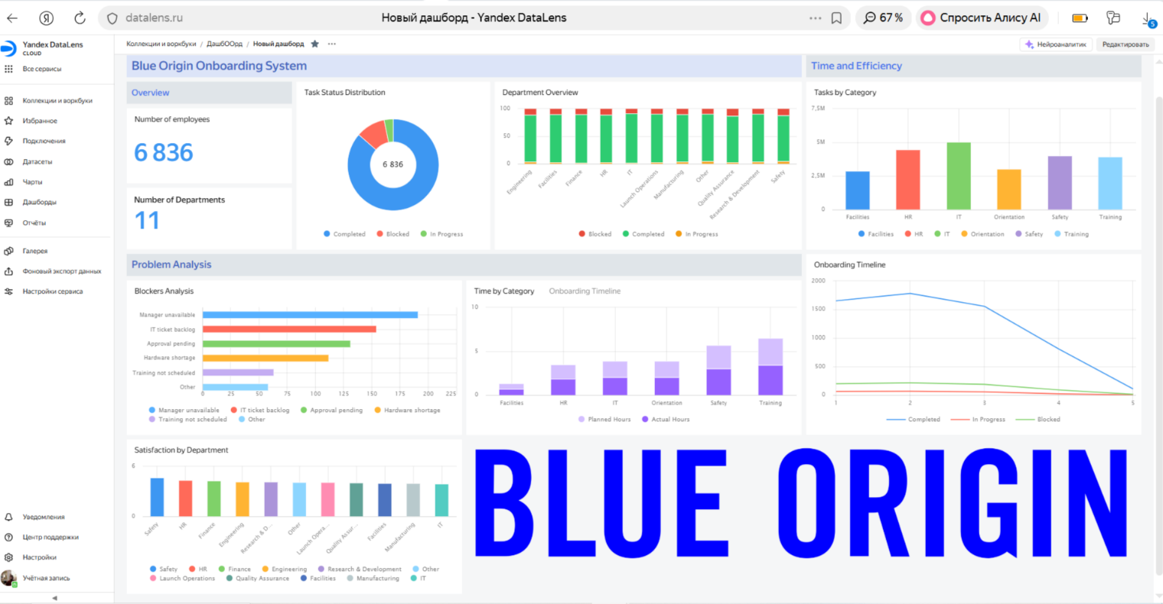

The Blue Origin Onboarding System dashboard provides a centralized view of the employee onboarding process for 6,836 employees across 11 departments.
It tracks overall completion status, task distribution by category, common blockers, departmental satisfaction scores, and a planned versus actual timeline. The pie chart shows all employees as completed, while task volumes highlight HR and IT as the heaviest-loaded functions. Satisfaction scores range from 4.8 in Safety down to 2.9 in IT, identifying departments needing improvement.
The dashboard also compares planned (2000) and actual (1500) onboarding hours, indicating better-than-expected efficiency. To make the dashboard actionable, alarms are proposed: blocked status exceeding two days triggers HR and manager notification; satisfaction below 3.5 initiates a process review; blocker frequency spikes or a 10% overrun in actual hours prompt targeted investigations. These alarms turn the dashboard into a proactive tool for continuous improvement.

- The link: https://datalens.yandex/y0eumjsc5zmki

- Dashboard and alarm-description
The Blue Origin Onboarding Dashboard provides a consolidated view of the onboarding process for employees across 11 departments. The dashboard is designed for HR leaders, department heads, and operations managers to monitor progress, identify bottlenecks, and track efficiency.
The dashboard includes the following key visualizations:
- Onboarding Status (Pie Chart) shows the overall completion status across all employees, segmented into Completed, In Progress, and Blocked.
- Task Status Distribution (Pie Chart) breaks down the volume of tasks by category (HR, IT, Orientation, Safety, Training), highlighting which functional areas carry the heaviest onboarding workload.
- Problem Analysis (Bar Chart) displays the frequency of blockers by reason (Manager unavailable, IT ticket backlog, Approval pending, Hardware shortage, Training not scheduled, Other), enabling quick identification of the most common obstacles.
- Department Overview (Bar Chart) illustrates the distribution of employees or tasks across departments (e.g., Engineering, IT, Operations, Construction, Safety, Training), helping to contextualize workload and satisfaction data.
- Time by Category (Bar Chart) compares estimated vs. actual hours for key categories (Training, Planning, Blocked, In Progress), providing insight into where onboarding time is spent.
- Onboarding Timeline (Line Chart) tracks the cumulative number of employees completing onboarding over time (weeks 0–5), allowing managers to assess overall process velocity.
Filters and slicers allow users to segment by department, recruitment source, or time period for deeper analysis.
To transform the dashboard from a passive reporting tool into an active management system, the following automated alarms are defined:
Alarm Trigger | Action
Any employee has a blocked status for more than 2 days | Notify HR and the employee’s manager to resolve the blocker.
Department average satisfaction score falls below 3.5 | Trigger a process review with the department head.
Actual onboarding hours exceed planned hours by more than 10% for any category | Initiate an efficiency audit.
Weekly blocker count increases by more than 20% compared to the previous week | Alert the relevant functional team (IT, HR, etc.).
More than 5 overdue tasks exist in a single category | Flag the category for additional resource allocation.
These alarms ensure that potential issues are addressed proactively, reducing delays and improving the overall onboarding experience.

Dashboard Evaluation of Ghaidaa Muhammad
Overall Score: 7.75 / 10

Strengths (Why It Scores Well)
- Clear dual narrative – The dashboard effectively communicates both a major success (110% user growth, high inquiry volume, 71% resolution rate) and a critical bottleneck (stockouts of key medications). This shows strong analytical thinking and business acumen.
- Good use of key metrics – Growth rate, resolution rate, and after-hours opportunity are prominently displayed, immediately conveying the main takeaways.
- Varied visualizations – A line chart for trends, pie chart for session status, and a table for top medications provide multiple perspectives, demonstrating an understanding of how to represent different data types.
- Actionable insight – The identification of Albuterol Inhaler and Amoxicillin as frequent stockouts directly links data to a clear business recommendation.
- Professional intent – The dashboard mimics real-world BI tools (layout, filtering panels), showing awareness of industry standards.

Minor Areas for Improvement (Why Not a 10)
- Layout polish – A few elements overlap or are misaligned (e.g., “Top Medications” text overlapping the stock status legend). A cleaner arrangement would enhance readability.
- Data labeling – The pie chart’s session status categories lack a direct legend; the resolution rate on the KPI card reads “10.0%” while the story states 71%—likely a formatting error that should be corrected.
- Consistency – Font sizes and KPI card styling are slightly inconsistent, which is common in student projects but can be refined.

Conclusion
This dashboard successfully tells a compelling data story, balances positive and negative findings, and demonstrates strong analytical thinking. The issues are primarily cosmetic and easily fixable. For a student project, it represents above-average work, meriting a 7.75 out of 10.

